**Deep Learning HW3**

- Vikramadithya Ivaturi

1. 503
2. Mean**:** 0.797654, Min: 0.100000, Max: 5.000000
3. 73.9%
4. 0.187601, They have a positive correlation
5. Scatter Plot showing the extra marks and final scores

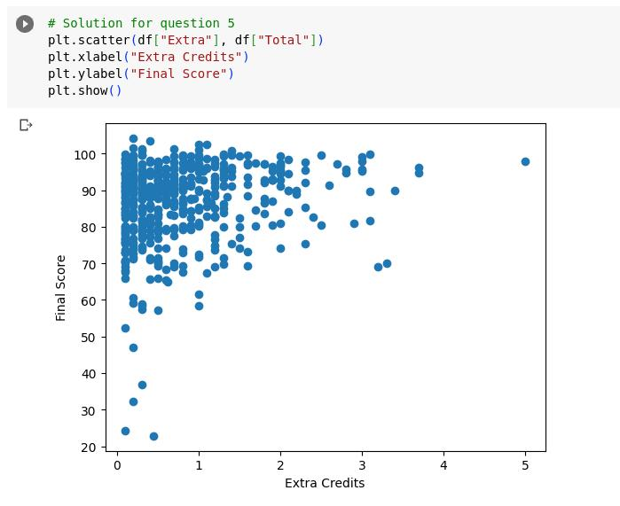

1. linear equation is: [[2.78665993]] *(extra marks) + [84.54015334]
2. RMSE: 10.711
3. Below is the screenshot for the graphical representation for the linear regression model.

